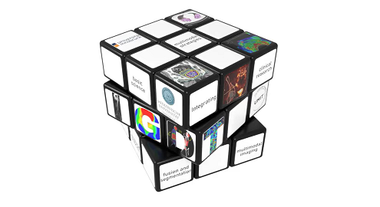IGDT - ART

Please send your complete application to e-mail!
Information under: phd-igdt-art (i-med.ac.at)
Part 1: Personal data
First, middle name
Last name
email address
gender
Date of birth
Nationality
Address
Street
Postal Code
City
Country
phone number
Language skills
language
level
language
level
language
level
Hobbies:

Part 2: Education
Education (BS)
University / College
Subject
Date from
date to
City
Country
Degree
Your grade
Best degree by university
worst degree by university
Status (complete / expected)
Education (MSc)
University / College
Subject
Date from
date to
City
Country
Degree
Your grade
Best degree by university
worst degree by university
Status (complete / expected)
Education (MD)
University / College
Subject
Date from
date to
City
Country
Degree
Your grade
Best degree by university
worst degree by university
Status (complete / expected)
Part 3: Research experience
Research experience (1)
Title of research project
Institution
Name of the supervisor
Date from
Date to
Short description of your research project:

Part 4: Referees
Referee #1

﻿First name
Last name
Email address
Title
Institution
Department
Street
Postal Code
City
phone number
Referee #2

﻿First name
Last name
Email address
Title
Institution
Department
Street
Postal Code
City
phone number

Part 5: Research interests
Please indicate the two PhD projects (P1 – P15) in IGDT that you find most interesting (choice is not binding) | P____  P____
First PhD Project (please fill in the project number (P1-P14) below:
P____:
What is your motivation to apply for this specific project? Please provide a short and concise scientific statement why this projects is of interest to you.

Second PhD Project (please fill in the project number (P1-P14) below:
P____:
What is your motivation to apply for this specific project? Please provide a short and concise scientific statement why this projects is of interest to you.

Part 6: Additional documents
Please provide a copy of your Diplomas / Certificates, transcript of grades, your CV and a motivation letter

